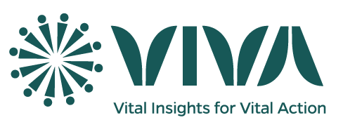**Description for the Community-Based Worker**

**Introduction**:

The [COUNTRY LEAD INSTITUTION] in partnership with the [COUNTRY SECOND LEAD INSTITUTION] is implementing the [NAME OF THE SYSTEM] in [COUNTRY]. The project aims to develop a nationwide sample registration system (SRS) to record pregnancies, births and deaths; and carry out verbal and social autopsy (VASA) of deaths identified. The [COUNTRY LEAD INSTITUTION] is looking to recruit community-based workers to assist the implementation of the [NAME OF THE SYSTEM] project in their communities.

The community-based worker is responsible for collecting information about community events (pregnancies, births and deaths) in its community. In carrying out duties, he or she will be assisted by key informants such as chiefs, religious leaders, community representatives, birth attendants, health professionals to support the community-based worker in the identification and reporting of vital events. He or she is expected to maintain good public relations to mobilize various resources in the community: work friendly and professionally with key informants and assist families to register births and deaths.

**Based in** [cluster/community name]

**Employment type:** X% (Part-time) for twelve months

**Key functions:**

* Conduct a baseline population assessment for the SRS by creating a list of all households and members (names, sex, age, and marital status)
* Conduct home visits to identify vital events (pregnancies, birth outcomes (miscarriages, stillbirths, live births) and deaths
* Collect data on vital events using the smartphone provided by the project
* Upload data to the secure cloud server managed by the [COUNTRY LEAD INSTITUTION]
* Report any issue with data collection to the supervisor (area with poor network, no response of participants and no compliance to the study)
* Assist family members to register birth and death at the civil registration office
* Conducting bimonthly household visits to identify vital events, including pregnancies
* Assist the VASA data collector to locate households to conduct the interview
* Report to VASA data collector

The community-based worker may be required occasionally to travel to the [COUNTRY LEAD INSTITUTION] [provincial or regional] office to discuss data collection and field management issues with the [NAME OF THE SYSTEM] team. He or she will be expected to be proactive in self-learning and may be asked to attend short-term classes to strengthen specific skills.

**Qualifications:**

* Be a resident of the community or nearby.
* Be literate, especially with basic knowledge or willing to learn how to use smartphone to collect and transfer data.
* Female candidates are encouraged
* The community-based worker may be an existing community worker (volunteer or government) who has time to take on the SRS responsibility.
* Endorsement from the community leaders.

The following qualifications are preferred:

* Ability to work both as part of a team and independently
* Living and working in the community
* Willingness to undertake at least a two-year assignment

The [NAME OF THE SYSTEM] team will work with each community to appoint an appropriate person who meets minimum criteria while also receiving full endorsement from the community leaders. The community-based worker will receive a monthly salary from the [NAME OF THE SYSTEM] project.